**Exp No: 6 Applying DML commands on Road Way Travels Tables. Data Manipulation Command**

**• Insert**

**• Update**

**• Delete**

**• Select**

insert into employees values(100, '2020-01-01', 'john', 'elton', 'M', '2021-04-20');

alter table employees add temp numeric;

update employees set temp = 10 where emp_id = 100;

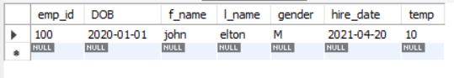

insert into employees value(102, '2021-03-23', 'G', 'P', 'M', '2021-05-05',12);

alter table employees drop temp;

insert into employees value(101, '2021-01-22', 'P', 'F', 'F', '1999-05-05');

insert into employees value(103, '2021-12-02', 'A', 'B', 'F', '1979-12-29');

insert into employees value(104, '2017-6-23', 'B', 'M', 'M', '1899-01-17');

insert into employees value(105, '2019-12-11', 'R', 'A', 'M', '2021-11-01');

select * from employees;

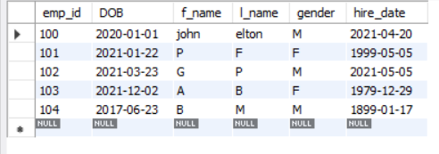

select distinct gender from employees;

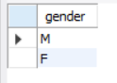

select count(distinct gender) from employees;

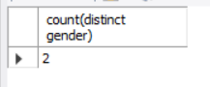

select DOB from employees where emp_id = 100;

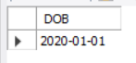

select * from employees where emp_id > 101;

